Tweaks.com Logon Changer for Windows 7

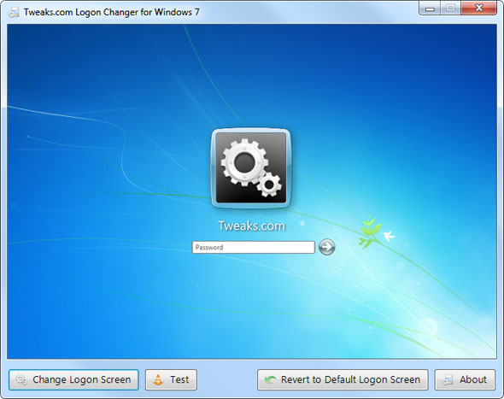

How To Use
The Tweaks.com Logon Changer for Windows 7 provides an easy way to customize the logon screen background with just a few clicks. Simply download the free application, run it and click Change Logon Screen.
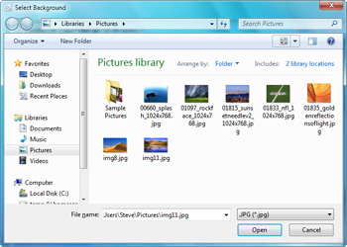
The application will prompt for the location of the new background image and then install the new screen behind the scenes. Tweaks.com Logon Changer will even provide a preview of your new background on a logon screen.
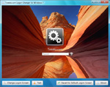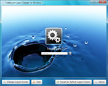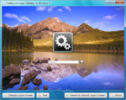
When you have settled on a good logon background, click the Test button to see it in action.
Key Features:
- Automatic Image Resize - Don't worry about the 245KB file size limit imposed by Microsoft. The Tweaks.com Logon Changer will give you the option to automatically resize and recompress the image to the highest quality possible. The original image is left untouched.
- Automatic Image Backup - All OEM backgrounds and any previously used backgrounds are automatically backed up when a logon background is changed.
- Absolutely Free - Just tell your friends about Tweaks.com :)
If you want the default Windows 7 logon screen back just click Revert to Default Logon Screen and the application will automatically uninstall any customized screens.

