What on earth is P2POver? To me, hell yeah it’s a godlike software that does godlike stuffs! It is a piece of software that is able to hijack your home network and limit the bandwidth of any computer connected to the home network. I used the word “hijack” because it can do its job without having to access to your router/hub/switch, which means you can limit the bandwidth of other people’s computer within the network without them noticing. However, some routers have the firewall that are able to block this program and make it unusable in the network.
华语教程：如何使用P2POver限制对家庭网络带宽 P2P终结者详细使用方法与教程说明
So, for those of you who are sharing their internet with their house mates or neighbors and are really frustrated on their actions hogging on bandwidth with P2P programs (such as ppstream and torrents) or extreme heavy download activity, you can use P2POver to limit the download and upload speed of any computer found in the same network. According to the author of this software, having two of this programs running within your network will force one of them to quit. It sounds crazy but yeah, please use this morally and ethically.

How to Use P2POver to Limit Bandwidth on Home Network
Before we go further, I must warn you that this software might cause your computer or router to be unresponsive and you will need to restart them for them to work again. So, if this problem repeats when you use the program, please stop using it. Use this software at your own risk.
First of all, download and install P2POver.
Step 1: This software is originally made by a Chinese guy. You will have to change the language of the software if you don’t understand Chinese. To change the language to English, launch P2POver, ignore the first pop-up at the first startup, and then follow the screenshots below to change the software’s language.
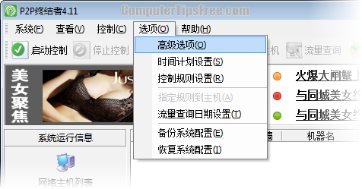
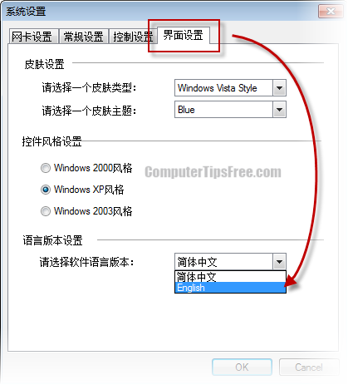
Step 2: Select the correct adapter which connects to the network. Go to Settings -> Advanced Option. Under the Adapters tab, select your adapter from the drop down menu.
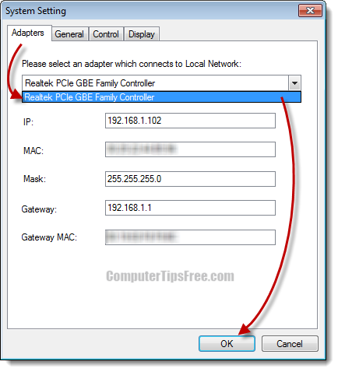
Step 3: Before setting the rules, we must first set the schedules of when the rules should work. Go to Settings -> Schedules Setting. Click the New button on the following window. Enter a name for the schedule and start setting up your schedule based on your need.
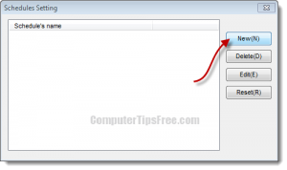
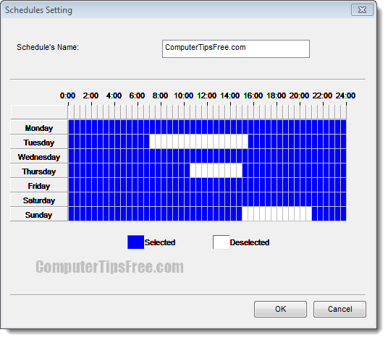
Step 4: Now we will set the rules. Go to Settings -> Rules Settings. Click the New button. Enter a name for the rules and select the schedule you just made from the drop down menu. After clicking Next, input the bandwidth limit of your choice. On the next screen, select the P2P programs you wanted to block. Follow the on-screen instruction to complete the rules settings. (P2POver able to block these programs: BT ppstream pplive qq直播 qq游戏 pp点点通 vagaa 酷狗 迅雷 pp狗 p8 foxy 电驴 卡盟.)
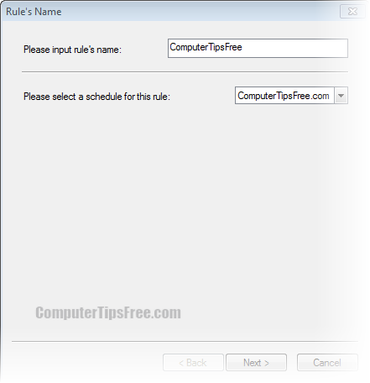
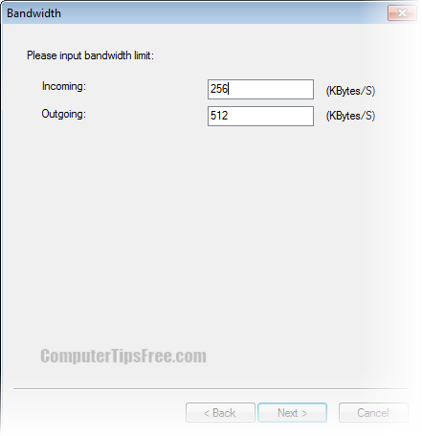
Step 5: Back on the toolbar, click on Scan to scan and detect all computers and devices connected to the network.
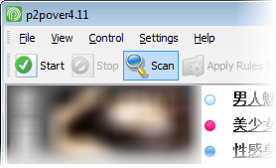
Step 6: Ok, now you can cap whoever bastards you hate. Right click the IP address of the fellow’s computer, select Apply Rules to Host Selected. Select the rule you just made and then click Ok. Right click the IP address again, select Control All. Lastly, click the Start button which appears beside Scan from the toolbar.
